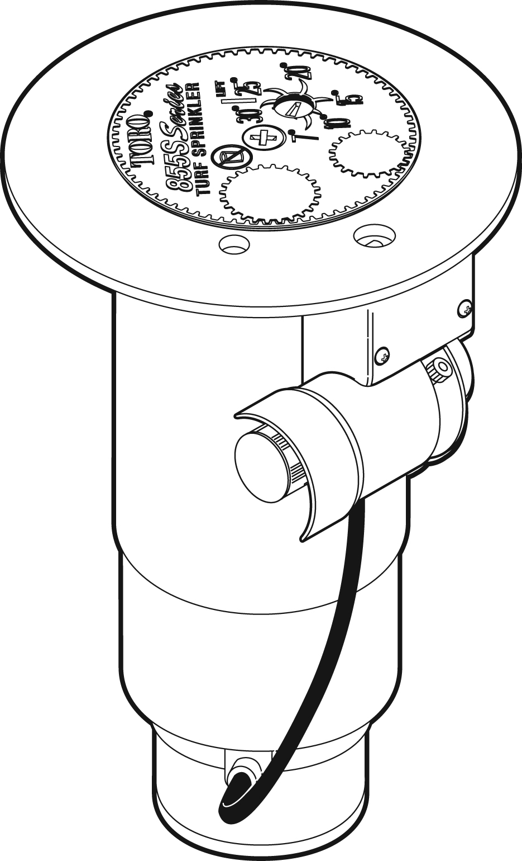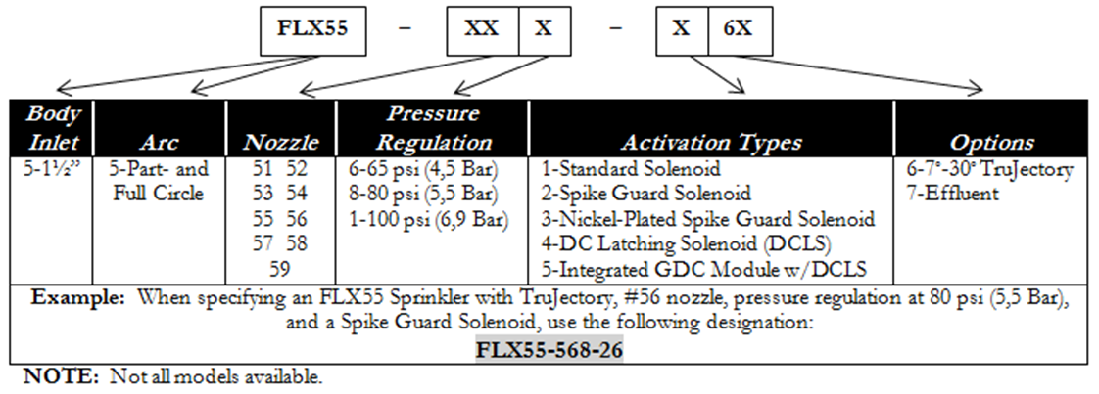

Specifications
- Radius: 52’–100’ (15,8–30,5m)
- Flow rate: 13.9–61.1 GPM (52,6-231 LPM)
- Arc: Bidirectional, part circle rotation, adjustable from 40°-330°, and true unidirectional 360° full-Circle rotation.
- Pilot Valve-selectable at 50, 65, 80 or 100 psi (3,5, 4,5, 5,5 and 6,9 Bar)
- Recommended operating pressure range: 65–100 psi (4,5–6,9 Bar)
- Maximum pressure: 150 psi (10,3 Bar)
- Minimum pressure: 40 psi (2,8 Bar)
- Activation types – Electric Valve-in-Head:
- Standard Solenoid:
  - 24 VAC, 50/60 Hz
  - Inrush: 0.30 A
  - Holding 0.20 A
- Spike Guard Solenoid:
  - 24 VAC, 50/60 Hz
  - Inrush: 0.12 A
  - Holding 0.10 A
  - Nickel-Plated Spike Guard Solenoid:
  - 24 VAC, 50/60 Hz
  - Inrush: 0.12 A
  - Holding 0.10 A
  - DC Latching Solenoid (DCLS):
  - Momentary low voltage pulse
  - Integrated GDC Module w/DCLS:
  - Momentary low voltage pulse
- Stator variations: 3
- Inlet size: 1.5” (40mm) ACME
- Body height: 11 5/8” (295mm)
- Body flange diameter: 7⁵/₈ ” (194mm)
- Pop-up height to nozzle: 3¼” (83mm)
- Pop-up height (overall): 4³/₁₆” (106mm)
- Weight:
  - 3.61 lbs. (1,6 kg)
  - 4.30 lbs. (2,0 kg) Integrated GDC Module
- Three inline nozzles; rotating stream pattern
- Precipitation rates:
  - Minimum: 0.50”/hr. (12,7mm/hr.)
  - Maximum: 1.00”/hr. (25,4mm/hr.)
- Main nozzles: 9 (51, 52, 53, 54, 55, 56, 57, 58 and 59)
- Trajectory: Adjustable from 7°–30° in 1° increments (24 positions)
- Apex and Radius:
15° | 25°
65 psi (4,5 Bar)
51 – 6’(1,8m)@51’(15,5m) | 13’(4m)@54’(16,4m)
52 – 6’(1,8m)@51’(15,5m) | 11’(3,4m)@64’(19,5m)
53 – 7’(2,1m)@59’(18m) | 13’(4m)@68’(16,5m)
54 – 8’(2,4m)@63’(19m) | 15’(4,6m)@74’(22,6m)
55 – 9’(2,7m)@66’(20m) | 15’(4,6m)@76’(23m)
80 psi (5,5 Bar)
56 – 8’(2,4m)@75’(22,9m) | 18’(5,5m)@83’(25,3m)
57 – 9’(2,7m)@74’(22,5m) | 19’(5,8m)@82’(25m)
58 | 18’(5,5m)@45’(13,7m)
59 | 21’(6,4m)@49’(14,9m)

Bidding Specifications

The sprinkler shall be capable of full-and part–circle operation and be a gear-driven rotary type. The sprinkler shall include a ratcheting riser feature that allows the user to adjust the position of the riser in the body without disassembly. The arc of the sprinkler shall be adjustable by the use of an adjustment band located between the nozzle base and riser. The left terminus of the arc shall be fixed, with the right position adjustable from a 40° arc minimum up to a 360° arc maximum. When the 360° arc adjustment position is reached, the sprinkler will rotate uni-directionally in the clockwise direction. The sprinkler shall be adjustable wet or dry, by hand, using no tools. The arc adjustment band shall identify the 90°, 180°, 270° and 360° arc positions. The end-of-arc dwell time shall not exceed 2 seconds and will generally be less than 1 second.
Rotation shall be accomplished by a water-lubricated compound cluster gear drive with balanced reversing gear plate. The drive assembly shall be driven by a spring-loaded, poppet-type, variable stator, sized to provide 3-minute, full-circle rotation speeds throughout the pressure range. The drive and stator assemblies shall be constructed of corrosion-proof plastic and stainless-steel components.

The sprinkler shall include a nozzle base clutching feature that allows the user to rotate the nozzle base in either direction, wet or dry, and hold it in one position during operation to allow for spot watering.

Water distribution shall be via three nozzles mounted in a 2¼”-diameter (57mm) plastic nozzle turret. The three nozzles shall be oriented in the same direction and elevate 3¼” (83mm) above the body when in operation. All nozzles shall be of a thread-in type accessible from the front with no other disassembly required. All nozzles are color-coded for easy identification of radius and gallonage performance capabilities, and shall be designed to allow any particle capable of passing through the riser screen to pass through the nozzle. The sprinkler shall be capable of accepting a fourth nozzle that can be installed 180° from the main nozzle to provide coverage behind the sprinkler. This back nozzle position shall be manufactured with a factory-installed plug that can be removed to accept over 50 different inner and intermediate nozzle combinations. The sprinkler shall be capable of accepting 9 different color-coded main nozzles and a main nozzle adapter, and 10 different color-coded inner/intermediate nozzles. The main nozzle shall incorporate a trajectory adjustment that provides a main nozzle discharge angle from 7° to 30° in 1° increments. Trajectory adjustment shall be capable while the sprinkler is in operation or not. The sprinkler shall identify the trajectory adjustment setting from the top of the sprinkler. Close-in watering distribution shall be achieved by an inner nozzle capable of adjusting the distribution profile to optimize uniformity. The cap shall identify the installed main nozzle and the date of manufacture.

The pilot valve assembly shall incorporate one of five electrical activation types (described below) to control the ON-OFF operation of the sprinkler. It shall provide four pressure-point selections (50, 65, 80 and 100 psi; 3,5, 4,5, 5,5 and 6,9 Bar), with a vandal-resistant locking feature that ensures the desired setting is maintained. The pressure points shall be graphically illustrated in psi and kg/cm2. The pilot valve assembly shall include a pressure-regulation feature that continuously monitors the operating pressure inside the sprinkler body, making the necessary adjustments to ensure the desired and set regulation pressure is maintained. The pilot valve assembly shall incorporate a manual control feature that is accessible from the top and allows the sprinkler to be manually selected “ON”, “OFF” or placed in the “AUTO” position awaiting commands from the control device. The manual selector shall be red in color for enhanced visibility. The pilot valve assembly shall be stamped with the manufactured date.

The sprinkler shall incorporate an electrical solenoid for activation of the integrated control valve in one of five activation types as described below.

Standard Solenoid
The Standard solenoid shall be suitable for 24 VAC, 50/60 Hz service with an inrush current of 0.30 A @ 50/60 Hz, and holding current of 0.20 A @ 50/60 Hz and shall be capable of withstanding a voltage surge of up to 9k volts in the common and normal modes without failure.
Spike Guard Solenoid
The Spike Guard solenoid shall be suitable for 24 VAC, 50/60 Hz service with an inrush current of 0.12 A @ 50/60 Hz, and holding current of 0.10 A @ 50/60 Hz. and shall be capable of withstanding a voltage surge of up to 20k volts in the common and normal modes without failure.

Nickel-Plated Spike Guard Solenoid
The Nickel-Plated Spike Guard solenoid shall be suitable for 24 VAC, 50/60 Hz service with inrush current of 0.12 A @ 50/60 Hz, and holding current of 0.10 A @ 50/60 Hz. and shall be capable of withstanding a voltage surge of up to 20k volts in the common and normal modes without failure. It shall also have a nickel-plated core to provide additional corrosion-resistance in potable and non-potable water applications.

DC Latching Solenoid
The DC latching solenoid shall be activated by a momentary low-voltage pulse that moves the plunger from the “OFF” to the “ON” position where it is maintained by a permanent magnet in the solenoid. To deactivate, a second momentary low-volt pulse is applied to move the plunger from the “ON” position to the “OFF” position. This activation type is generally used with a GDC module that is remotely located.

Integrated GDC Module
The Integrated GDC Module activation type incorporates the GDC module attached to the outside of the sprinkler body and includes a DC latching solenoid for activation of the control valve. The DC latching solenoid shall be activated by the Integrated GDC module with a momentary low voltage pulse that moves the plunger from the “OFF” position to the “ON” position where it is maintained by a permanent magnet in the solenoid. To deactivate, a second momentary low-volt pulse is applied to move the plunger from the “ON” position to the “OFF” position.

The internal valve assembly shall be a piston-type that vents to the atmosphere, providing valve friction loss of less than 5 psi (0,34 Bar). The sprinkler shall be designed to provide smooth valve closure in excess of two seconds to minimize damage resulting from surges and water hammer. All valve seals shall be constructed of natural rubber. The valve seat seal shall be constructed of fabric-reinforced natural rubber. The electric valve assembly shall incorporate a 100-mesh stainless-steel screen for the control water, preventing entry of foreign materials into the pilot valve assembly.

The sprinkler body and cap shall be injection-molded from ABS – a corrosion-proof, impact-resistant, UV-resistant, heavy-duty, engineering-grade plastic material. The cap and nozzle base shall incorporate a pull-up feature that provides improved serviceability of nozzles and riser. The sprinkler shall have two plastic filter screens – a top-serviceable coarse rock screen in the body inlet sized to prevent entry of larger foreign material from entering the body, and a finer screen threaded into the riser, sized to prevent foreign material from clogging the nozzle.

The sprinkler shall have a riser/body seal assembly that regulates flushing during pop-up and retraction to clear any debris from around the riser, and a heavy-duty, stainless-steel spring to ensure positive retraction. The riser is sealed by a durable, over-molded urethane ring on the seal retainer. Sprinkler flush rate shall not exceed 5 GPM (18,9 LPM).

The sprinkler shall be capable of identifying the use of effluent water via a lavender-colored marking. The sprinkler cap shall indicate model designation, nozzle number and manufacturing date code.

The sprinkler shall be of a pop-up design with an overall height of 11 5/8” (295mm), a body flange diameter of 7⁵/₈ ” (194mm), a cap diameter of 3⁵/₈ ” (92mm) and a pop-up stroke of 4 3/16” (106mm). The sprinkler shall have a 1½” (40mm) ACME female-threaded inlet. The sprinkler shall be capable of covering ___ feet radius at ___ pounds per square inch pressure with a discharge rate of ___ gallons per minute.

The sprinkler shall be developed and manufactured by an ISO 9001-certified facility. The sprinkler shall be model number __________ and shall be manufactured by The Toro Company, Irrigation Division.

Recommended Installation Procedures
The FLX55-6 sprinkler is designed specifically for turf areas requiring _____ coverage. These products offer the most economical method of irrigation where flows and system pressures are available to support a greater radius.

The FLX55-6 sprinklers should be specified for installation on a Toro swing joint. The swing joint should be specified as a triple-swing type, allowing movement up, down, laterally and at an angle-to-grade. The sprinkler should be installed with the body cover at grade.

Individual sprinkler head control is accomplished using a single FLX55-6 valve-in-head sprinkler per controller station. Use of the valve-in-head model will allow individual station control, and is particularly useful for irrigating distinct turf regions at unique application rates.

FLX55-6 sprinklers are engineered to provide a smooth, consistent curtain of water across the arc, with provision made for head-to-head coverage. For proper spacing, ensure that system design and installation accounts for prevailing wind conditions and body cover angle-to-grade.

It is recommended that sprinklers are installed 2” (5cm) from hardscaping and 6”-12” (15,2-30,5cm) from buildings or other vertical impediments to allow for normal maintenance procedures and to minimize overspray on buildings. Where possible, sprinkler heads should be installed in a manner that will minimize nozzle stream contact with trees, controller enclosures, shrubbery or other obstructions.

